DATA ANALYSIS PROJECT REPORT

Project Title | Global Video Game Sales Trends and Performance Analysis
Student Name | MD.Al -TAMISH HOSSAIN  HUZIFA ISLAM
Student ID | 25-60896-1  25-61070-1
Course / Section | Python
Instructor | MD. TANZEEM RAHAT
Date of Submission | 3 May 2026

1. Executive Summary
This project analyzes the "vgsales.csv" dataset, which contains a list of video games with sales greater than 100,000 copies. The primary goal was to identify which genres and platforms dominate the global market and to categorize game success using statistics. Through data cleaning and exploratory data analysis using Pandas, NumPy,Seaborn,and Matplotlib, several key insights were discovered. specific platforms like the DS and PS2 showed the highest volume of game releases. By applying quantile-based performance categorization, the study highlighted that while a few "High Performers" drive massive revenue, the majority of the market consists of lower-volume sales titles.

2. Introduction and Project Objectives

Item | Your Content
Dataset name | Video Game Sales (vgsales.csv)
Dataset source | https://www.kaggle.com/datasets/dandanjia/vgsales-csv
Main project goal | global video game sales by analyzing genre, platform, and regional trends.
Research Question 1 | Which video game genres achieve the highest average global sales?
Research Question 2 | How do the top 8 gaming platforms compare in terms of the total number of game releases?
Research Question 3 (optional) | How are games distributed across performance categories (High, Average, Low) based on their global sales?

3. Dataset Description
The dataset contains 16,598 records of video games. Each row represents a specific game release on a specific platform, including its rank, title, platform, year of release, genre, publisher, and sales figures broken down by North America, Europe, Japan, Other regions, and the Global total Sales.

3.1 Basic Dataset Information
Property | Value
Number of rows | 16,598
Number of columns | 11
Data types present | numerical ,categorical,Year
Target or key variable(s) | Global Sales
Potential issues observed at first glance | Missing year Value,Publisher,0 Value on Regional

3.2 Initial Observations
The dataset was found to have missing release years for several titles. The 'Year' column was initially stored as a float due to NaN values, requiring conversion.

4. Data Cleaning and Preparation
[Explain how you cleaned and prepared the dataset before analysis. Do not just list the steps. Explain the problem, the action you took, and why it was reasonable.]
Issue Found | Action Taken | Reason / Justification | Code Reference
Missing publisher | Filled with 'Unknown' | genre/platform analysis without dropping data. | df['Publisher'] = df['Publisher'].fillna('Unknown')
Missing/NA Years | Dropped rows with null or 'N/A' years | Accurate time-based analysis (decades) | df = df[df['Year'].notna()]  df = df[df['Year'] != 'N/A']
Incorrect Data Types | Converted 'Year' to integer | Fixed time unit to int | df['Year'] = df['Year'].astype(int)
Regional 0 Sales | Replaced 0 with regional mean | to handle potentially under-reported data while maintaining statistical averages. | # Calculate the average  NA_Avg = df['North America Sales'].mean()  EU_Avg = df['Europe Sales'].mean()  JP_Avg = df['Japan Sales'].mean()  # Replace 0 with the average value  df.loc[df['North America Sales'] == 0, 'North America Sales'] = NA_Avg  df.loc[df['Europe Sales'] == 0, 'Europe Sales'] = EU_Avg  df.loc[df['Japan Sales'] == 0, 'Japan Sales'] = JP_Avg

5. Feature Engineering

Decade Column | df['Decade'] = (df['Year'] // 10) * 10  df['Decade_Label'] = df['Decade'].astype(str) + 's' | 10-year blocks to visualize industry growth across generations.
Performance Category | function using 25th and 75th percentiles of Global Sales  q1 = df['Global Sales'].quantile(0.25)  q3 = df['Global Sales'].quantile(0.75)  # categorization logic  def categorize_performance(sales):  if sales > q3:  return 'High Performer'  elif sales < q1:  return 'Low Performer'  else:  return 'Average Performer'  # crating performence column  df['Performance Category'] = df['Global Sales'].apply(categorize_performance) | Segments the market into High, Low, and Average performers for better comparison.

6. Analysis Methodology
• Pandas was used for loading the dataset, renaming columns, and grouping data by 'Genre' and 'Platform' to calculate sums and means.
• NumPy was used for statistical calculations, specifically for calculating quantiles to define the for the 'Performance Category'.
• Matplotlib/Seaborn was used to create visual representations, including pie charts for genre distribution and bar charts for platform popularity and performance segments.

7. Analysis and Visualizations

Average Global Sales by Genre
Analysis: Grouped the data by Genre and calculated the mean Global Sales for each to see which genre is most profitable per title.
Figure 1. Distribution of average sales across different game genres.
Interpretation: Platformer,Shooter,and Role playing games lead the market. This suggests that publishers focusing on these genres have a higher statistical probability of achieving better average sales per game.

Top 8 Platforms by Release Count
Analysis: Counted the frequency of each platform to identify where most development occurred.
Figure 2. Comparison of game release volume across the top 8 gaming platforms.
Interpretation: The Nintendo DS and PlayStation 2 had the largest libraries, indicating long life cycles and high developer adoption.

Market Distribution by Performance
Analysis: Categorized games into performance tiers based on the global sales distribution.
Figure 3. Number of games classified as High, Average, or Low performers. Interpretation: The industry is heavily weighted toward "Average" and "Low" performers, with only the top 25% of games reaching "High Performer" status.

7.1 Reaseach Question 1
Which video game genres achieve the highest average global sales?
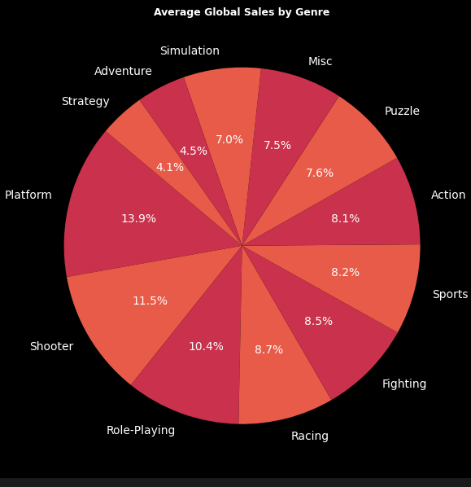
Figure 1. Distribution of average sales across different game genre
Platform,Shooter,and Roleplaying games lead the market. This suggests that publishers focusing on these genres have a higher statistical probability of achieving better average sales per game.
Interpretation:. Platform,Shooter,and role playing games lead the market. This suggests that publishers focusing on these genres have a higher statistical probability of achieving better average sales per game.

7.2 Research Question 2

Counted the frequency of each platform to identify where most development occurred.
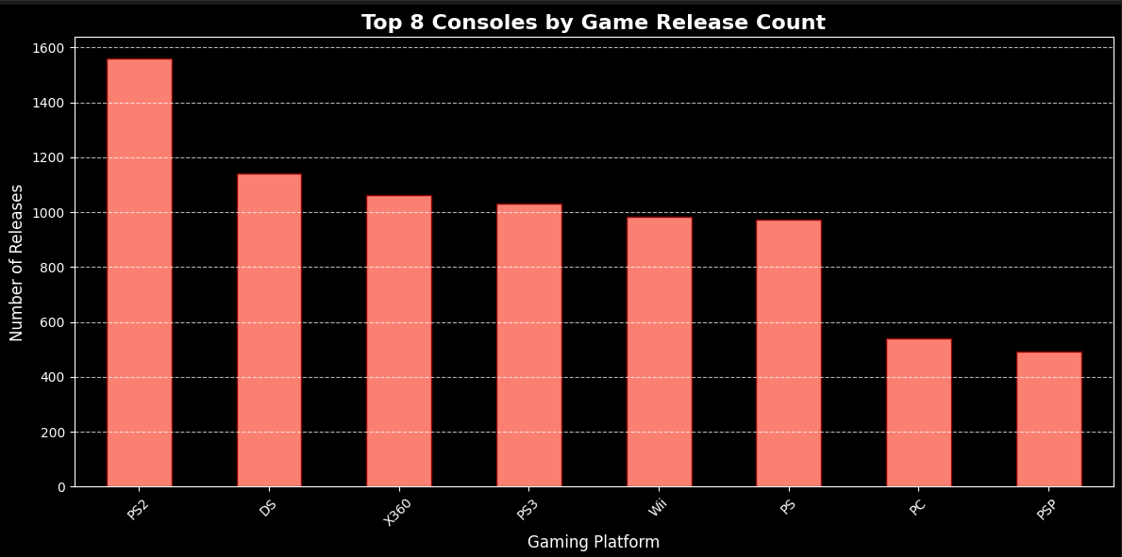
Comparison of game release volume across the top 8 gaming platforms
Interpretation: The Nintendo DS and PlayStation 2 had the largest libraries, indicating long life cycles and high developer adoption.

7.3 Research Question 3
Analysis : Categorized games into performance tiers based on the global sales distribution.

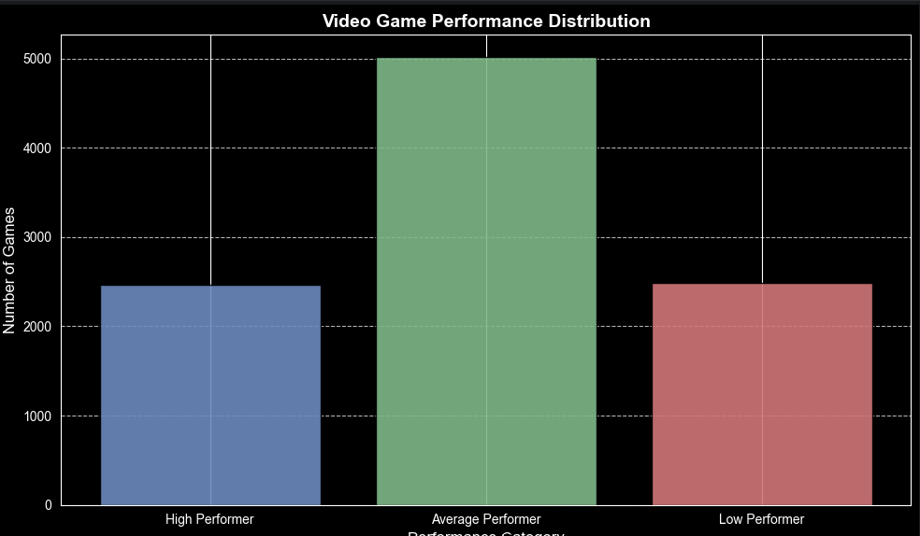
Number of games classified as High, Average, or Low performers. Interpretation: The industry is heavily weighted toward "Average" and "Low" performers, with only the top 25% of games reaching "High Performer" status

8. NumPy-Based Custom Computation

Component | Description
Computation used | Quantile-based thresholding
Purpose | To objectively define what constitutes a "High" or "Low" performing game.
Formula or logic | # Calculate the thresholds using quantiles for Performence  q1 = df['Global Sales'].quantile(0.25))  q3 = df['Global Sales'].quantile(0.75)
Result / takeaway | Games with global sales > 0.48M (q3) are High Performers; those < 0.06M (q1) are Low Performers.

9. Key Findings
- Growth Trend: The 2000s saw the largest spike in game releases compared to previous decades.
- Regional Correlation: Sales in North America and Europe show a much higher correlation to each other than to sales in Japan.
- Sales Skew: A very small percentage of games (the top 25%) account for a disproportionately large share of global revenue
- Platform Longevity: The PS2 and DS were the most active platforms in terms of total game releases.
- Genre Dominance: Action and Sports games are the most prolific and profitable genres globally.

10. Limitations
The dataset is limited to games with sales over 100,000 copies, meaning smaller indie games are excluded, potentially biasing the results toward AAA titles. Additionally, there is missing data for "Year" in several hundred records which could affect the accuracy of the decade-based analysis.

11. Conclusion
The analysis of the video game sales dataset highlights the dominant role of Action and Sports genres and the historical significance of platforms like the PS2 and DS. By using statistical binning, we found that the market is highly competitive, with few games achieving high-tier success. Future work should include modern digital sales data to see if these trends hold in the era of online storefronts.

12. References / Dataset Source
https://www.kaggle.com/datasets/gregorut/videogamesales

Final Submission Checklist
- ☐I included my GitHub repository link or Google Colab notebook link in the Google Sheet provided by the instructor.
- ☐ I attached the project report as a separate file.
- ☐ My report includes dataset source, project objective, cleaning steps, feature engineering, analysis, visualizations, findings, limitations, and conclusion.
- ☐ My code uses Pandas, NumPy, and Matplotlib meaningfully.
- ☐ All bracketed placeholder text and helper notes were replaced or deleted before submission.

